

*If child surpassed the Winter Goal, insert **Spring Goal** for the Specific Probe. (LN)

**See Benchmark Table Below**

**24-25 CBM Goal Setting Cheat Sheet**

**Cycle 2 (January 6th – January 31st)**

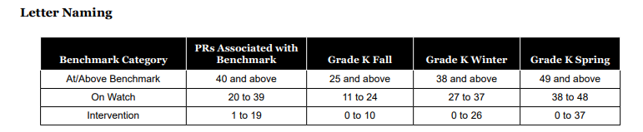

**We are setting goals for:**

* **Letter Naming (LN)**
* **Letter Sounds (LS) / Phoneme segmentation(PS)**
* **Numeral Recognition (NR)/ Quantity Comparison(QC)**

**Probe: Letter Naming**



**Step 1:** Next to each child’s name-**Click add goal**

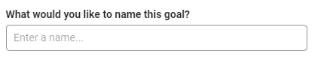

**Step 2:** Name the Goal- **CYCLE 2- Letter Naming**

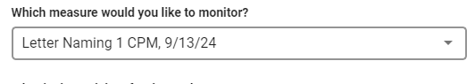

**Step 3:** Select the **Letter Naming Probe**

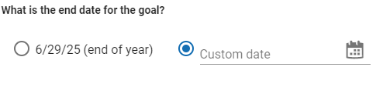**Step 4:** Goal End date- **Custom date**

**1/31/2025**

**Step 5:** What type of goal you would like to set? **Custom Goal**

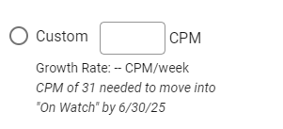

**38**

**Step 6: Save Goal**

**24-25 CBM Goal Setting Cheat Sheet**

*If child surpassed the Winter Goal, insert **Spring Goal** for the Specific Probe. (LS)

**See Benchmark Table Below**

**Cycle 2 (January 6th – January 31st)**

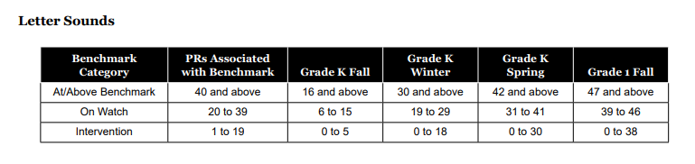

**We are setting goals for:**

* **Letter Naming (LN)**
* **Letter Sounds (LS) / Phoneme segmentation(PS)**
* **Numeral Recognition (NR)/ Quantity Comparison(QC)**

**Probe: Letter Sounds**



**Step 1:** Next to each child’s name-**Click add goal**



**Step 2:** Name the Goal- **CYCLE 2- Letter Sounds**

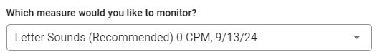

**Step 3:** Select the **Letter Sound Probe**

**Step 4:** Goal End Date- **Custom date**

**1/31/2025**

**Step 5:** What type of goal you would like to set? **Custom Goal**

**30**

**Step 6: Save Goal**

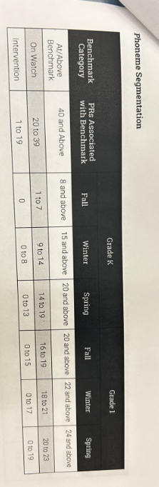

 **24-25 CBM Goal Setting Cheat Sheet**

*If child surpassed the Winter Goal, insert **Spring Goal** for the Specific Probe.

**See Benchmark Table Below**

**Cycle 2 (January 6th – January 31st)**

**Probe: Phoneme Segmentation**



**Step 1:** Next to each child’s name-**Click add goal**



**Step 2:** Name the Goal- **CYCLE 2- Phoneme Segmentation**

**Step 3:** Select the **Phoneme Segmentation**

**Step 4:** Goal End Date- **Custom Date**

**1/31/2025**

**Step 5:** What type of goal you would like to set? **Custom Goal**

**15**

**Step 6: Save Goal**

 **24-25 CBM Goal Setting Cheat Sheet**

*If child surpassed the Winter Goal, insert **Spring Goal** for the Specific Probe.

**See Benchmark Table Below**

**Cycle 2 (January 6th – January 31st)**

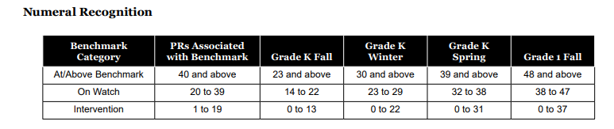

**Probe: Numeral Recognition**



**Step 1:** Next to each child’s name-**Click add goal**



**Step 2:** Name the Goal- **CYCLE 2- Numeral Recognition**



**Step 3:** Select the **Numeral Recognition Probe**

**Step 4:** Goal End Date- **Custom Date**

**1/31/2025**

**Step 5:** What type of goal you would like to set? **Custom Goal**

**30**

**Step 6: Save Goal**

 **24-25 CBM Goal Setting Cheat Sheet**

*If child surpassed the Winter Goal, insert **Spring Goal** for the Specific Probe.

**See Benchmark Table Below**

**Cycle 2 (January 6th – January 31st)**



**Probe: Quantity Comparison**



**Step 1:** Next to each child’s name-**Click add goal**



**Step 2:** Name the Goal- **CYCLE 2- Quantity Comparison**

**Step 3:** Select the **Quantity Comparison**

**Step 4:** Goal End Date- **Custom Date**

**1/31/2025**

**Step 5:** What type of goal you would like to set? **Custom Goal**

**19**

**Step 6: Save Goal**